A
One day workshop on “Building Awareness on Intellectual Property Rights” was organized by faculty of Computer Science & Applications (AGI) with an association and sponsorship by Uttarakhand State Council of Science & Technology (UCOST), Dept of Science & Technology, (Government of India) on 20th April, 2018.
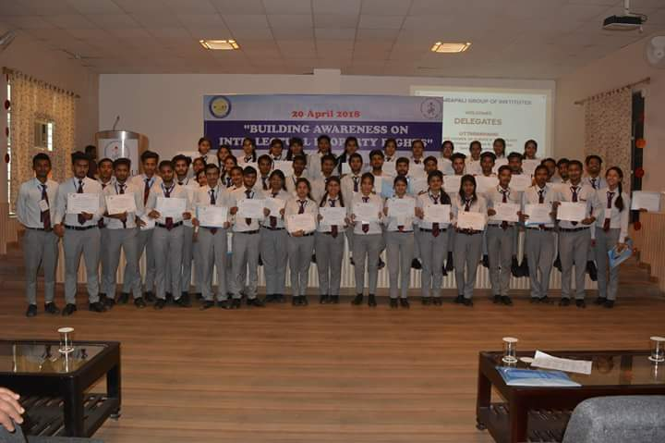
The workshop commenced with an inaugural session and lamp lightning ceremony by the dignitaries from UCOST and honorable management of AGI, which was followed by Saraswati vandana. After this, keeping the AGI tradition the honorable management of Amrapali family facilitated the guests with bouquet and mementos. Mr. N. S. Dasila on behalf of FCSA, welcomed the experts from UCOST for the workshop and gave a brief introduction to the audience about the sessions scheduled for the day. The workshop was divided into four sessions of knowledge sharing, with a high tea and lunch break in between.
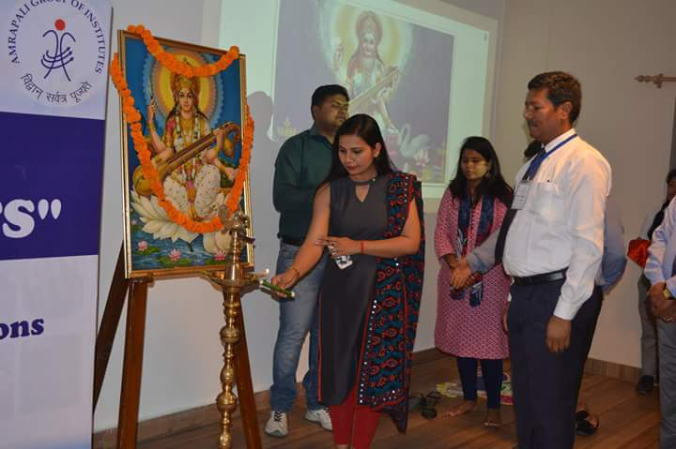

Session 01:
Speaker: Dr. Anju Rawat, Scientist-B, UCOST
This session covered the concept and basic knowledge about IPR i.e. Patent, Trademark, GI & Designs, Layout Designs etc. The expert gave an insight of the Intellectual Property Rights and defined that how a single device like a mobile phone can have more than 256 plus patents for its different components. Different forms of IPR such as Literary/Artistic work and Industrial work were categorized and explained with the help of daily life examples to the audience for clear understanding. It was also made very simple to understand that what can and what cannot be called an invention. Various criteria for patentability were discussed with help of pictorial representation. Other aspects of IPR, such as Geographical Indications (GI) and Trade secrets were also discussed in brief, as it was to be delivered by other experts in upcoming sessions.
Session 02:
Speaker: Mr. Himanshu Goel, Project Scientist, UCOST
This session covered the concept of patenting system in India & role of Patent Information Center (PIC) in Uttarakhand. The lecture concentrated on sensitizing the importance of Patents and also to have an idea of patent registration process and its enforcement. Expert presented the scenario of patent filing in India, which showed a great concern as the number is very less in comparison to other developing countries and small countries that are based on skill driven economies. He discussed about the procedure of granting the patent and also focused on the hierarchy and working of Indian Patent Office. A very descriptive flowchart was explained regarding the entire process of patenting from filing of application to grant/revoke/amendment of the patent. Role of UCOST in helping out the applicant to register for patent was also described and a promise to help anytime was also assured.
Session 03:
Speaker: Ms. Swatee Rawat, Scientific Trainee, TIFAC, UCOST
This session was focused on the importance of copyright and copyright system in India. The copyright Act 1957 was discussed with all the forms that come under this law. The definition of the term ‘exclusive rights’ wa discussed in detail, with all the points that come under them. Very good examples were quoted from movies, literature and daily life to explain the thin line between copyright infringement and fair use of rights. The role of judiciary was also brought into notice. The details along with fee structure on how to file the copyright was shared with the audience.
Session 04:
Speaker: Ms. Kamika Chaudhary, Scientific Trainee, TIFAC, UCOST
This session focused on Trademark and Industrial design. The issue such as what can be registered under trademark was explained in very effective way with the help of examples and case studies. Different types of Trademarks were explained with examples. Duration and fees for registration process along with Infringement laws were highlighted. It was also taught that how Design protection and aesthetic aspects of the products in an industry can be protected with the Industrial design trademarks.
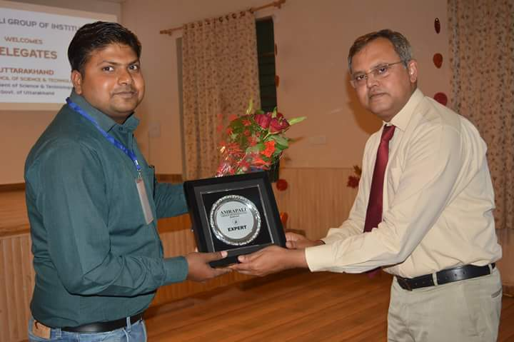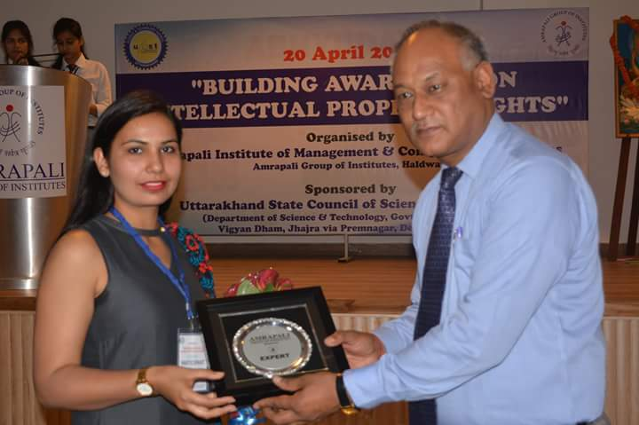

At the end of all sessions, a Valedictory speech with vote of thanks was delivered by Dr. M. K. Pandey (Director, FCSA), thanking the delegates for spearing their valuable time to enlighten the faculty and students of Amrapali Family with their expertise on IPR. A thank note was also delivered to all the committee members, technical team, participating faculty members and students who helped in making this event a success

