In today’s era, there is a need to provide students with the strength and capability so that can adapt themselves to the fast changing nature of computing world and drag their attention from bookish knowledge to practical aspect. Focusing on this aspect a day‘s workshop was organized by Faculty of Computer Science & Applications (AGI), on “Hybrid Application Development” for the students of BCA and B.Sc. (CS/IT) from other Universities, Institutes and Colleges. The main aim of the workshop was to provide a platform to all the aspiring technocrats, so that they can learn and practice the practical implementation of new computing science technologies.
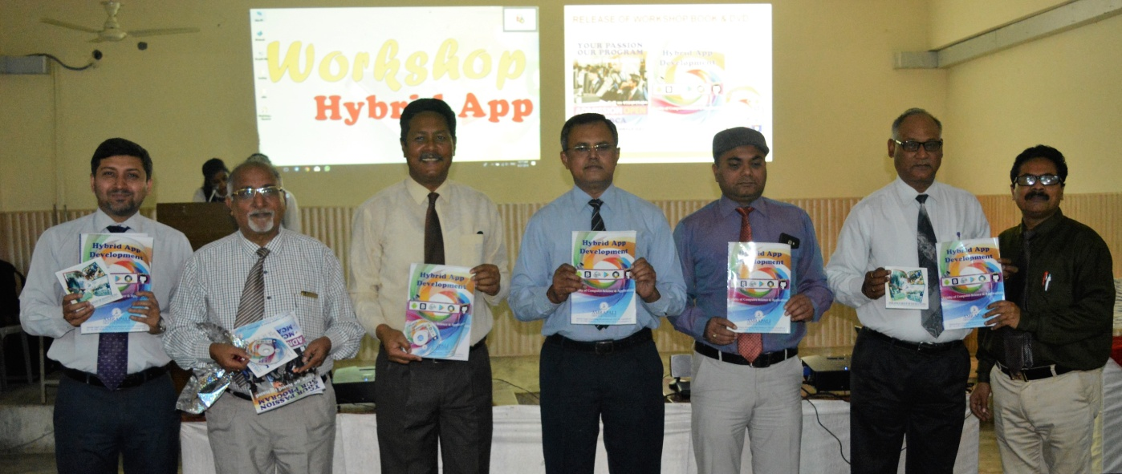
The workshop commenced with lamp lightning ceremony followed by seeking prayers and blessings of Goddess Saraswati. In this auspicious occasion, Dr. P. K. Shah (Registrar, AGI), Dr. S. K. Singh (COO), Dr. Ritvik Dubey (Director, FCBM) and Dr. A. P. Papreja (Director, AITS) showed their benign presence and inaugurated, FCSA’s departmental book on “Hybrid Application Development”.
Workshop Coordinator, Dr. M. K. Sharma announced the opening of workshop, where more than 100 students from 16 different Institutes such as, Jai Arihant Institute (Haldwani), Pal College (Haldwani), DSB campus (Nainital), SIMT (Kashipur), IMT (Kashipur), VCMT (Gaulapaar), SSJ Campus (Almorah) etc. were present.
In the first session Mr. Mukesh Joshi, discussed about the technical details of open source database i.e. NoSQL(MongoDB). He taught about the practical importance of MongoDB and its support towards unstructured databases. With respect to this Dr. Naveen Tewari focused on the practical use of Bootstrap technology.
In the second session Dr. Nitin Deepak and Dr. Naveen Tewari taught the students about the technical and practical specifications of PhoneGap framework provided by Adobe Systems. In continuation to this, they taught the students to develop mobile applications using PhoneGap and GitHub. They also showed that how this application can be deployed in Google’s play store.
In the end Prof. (Dr.) M. K. Pandey (Director, FCSA) addressed and thank all the students and faculty members from different Institutes for their participation in the workshop. On behalf of FCSA and AGI, he declared end of the workshop with a promise to organize more of such technical and educating workshop in future.
On this occasion the management board (AGI) and faculty members blessed the students with a bright and successful career.

