EVENTS ORGANISED BY FTCA DEPARTMENT :
- WORKSHOP ON E-WASTE
Amrapali Institute of Technology & Sciences and Vincular Testing Labs India Pvt Ltd jointly organized a Workshop on E- Waste Management on 22nd November 2019.
Experts from Vincular Testing Labs Mr. Neeraj Verma and Mr. Shubham Dwivedi (also an Amrapali Alumnus) discussed the various environmental and human issues related to E Waste.
Prof. (Dr.) Manoj Pandey, Director FTCA, appreciated the efforts of Vincular Testing Labs for their exceptional work in the field of E Waste Management. He also appreciated the hard work of Amrapali Alumni working in different positions at Vincular. The Workshop, coordinated by Mr. Anurag Bhatt and Dr. Suresh Wariyal, was attended by students of B. Tech, BCA and Polytechnic Diploma Courses. The workshop enlightened the students regarding existence, hazards and management of E-Waste.
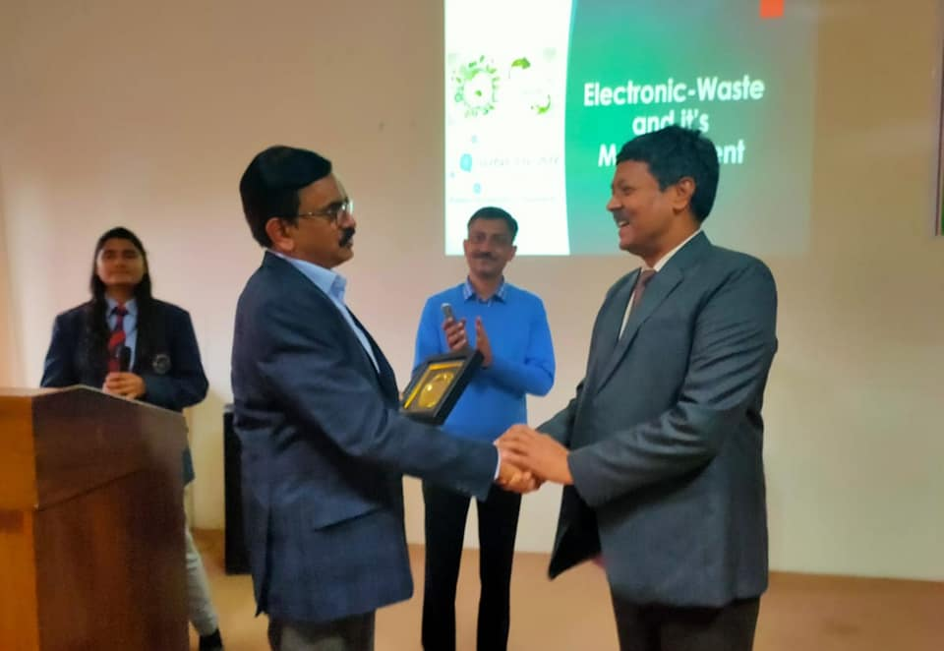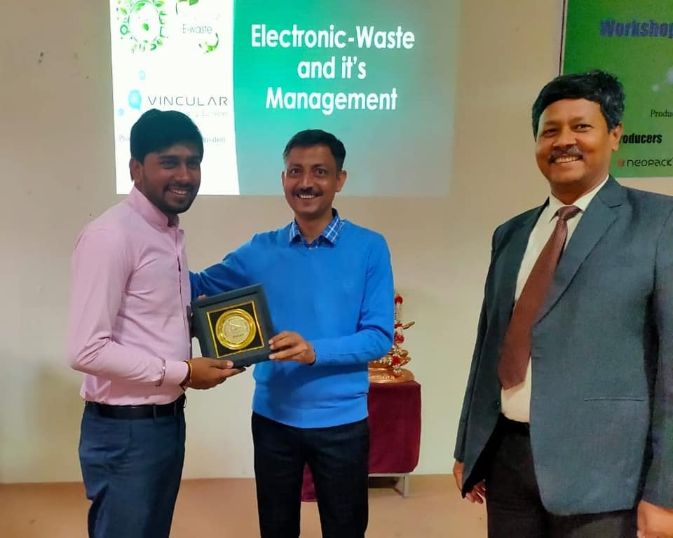
- Recreational Cum Educational Tour
The Students of Computer Science & Engineering Department went on a Educational cum Recreational Trip to Jaipur between 12th and 16th October 2019. The students visited Dotsquares Pvt. Ltd., a CMMI Level 3 Certified Company, in Jaipur. The students attended a session on Project Management at Dotsquares Pvt. Ltd. The students were also informed about the Internship and Employment Opportunities at Dotsquares.
The Industry visit was followed by Sight Seeing in Jaipur. The students visited various Tourist Spots including Amer Fort, Birla Mandir, Bapu Bazaar, Johari Bazaar, Albert Hall Museum, Nahar Garh Fort, Jal Mahal, Amar Jawan Jyoti, World Trade Park, Hawa Mahal, Pink Square Mall, Jantar Mantar, City Palace, Masala Chowk. The students were accompanied by Mr. Deep Chandra Andola and Ms. Vinita Adhikari.
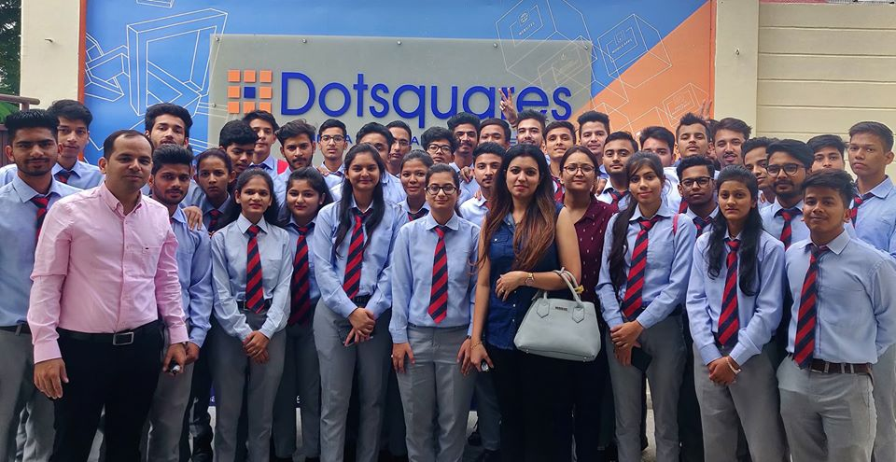
3) WORKSHOP ON INTERNET OF THINGS (IOT) WITH PYTHON

Faculty of Technology and Computer Applications, Amrapali Group of Institutes organised a One Day Workshop on "Internet of Things (IOT) with Python" today on 14th September 2019.
The Workshop started with the Lamp Lighting Ceremony followed by the Welcome Address by Prof (Dr.) Manoj Pandey, Director wherein he discussed the latest trends and developments in the Computing World. Dr. Sanjay Dhingra, CEO interacted with the students and congratulated the Faculty Members for their initiative of organising the workshop. He asserted that the Institute should organise similar workshops in the future too.
The Workshop was attended by more than 300 B. Tech/ MCA / BCA/ B. Sc (CS/ IT) students from AGI and nearby Technical Institutes.
Mr. Pramod Joshi introduced the theme of the workshop. The Resource Persons for the Workshop were Dr. Ashish Khare, Mr. Ankush Joshi and Mr. Sachin Verma. The Vote of Thanks was proposed by Dr. Mukesh Joshi, Workshop Coordinator.
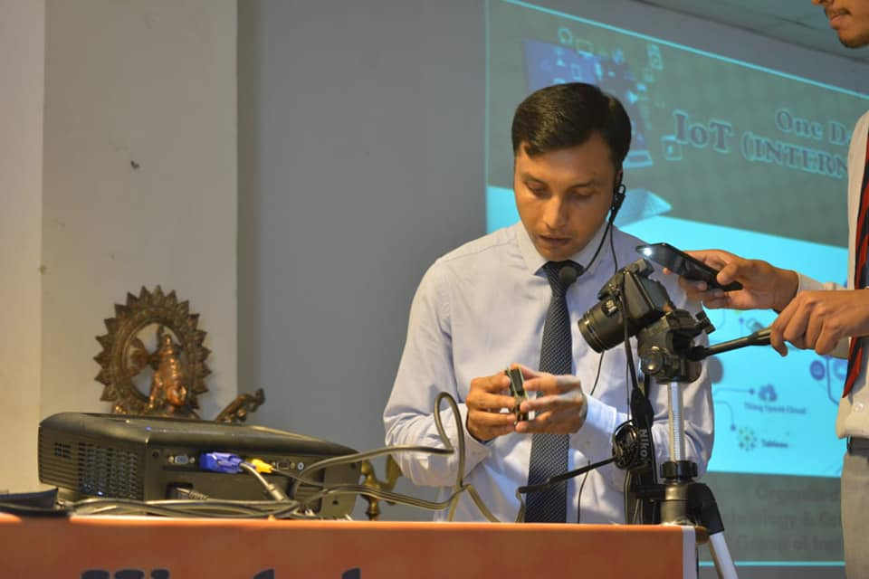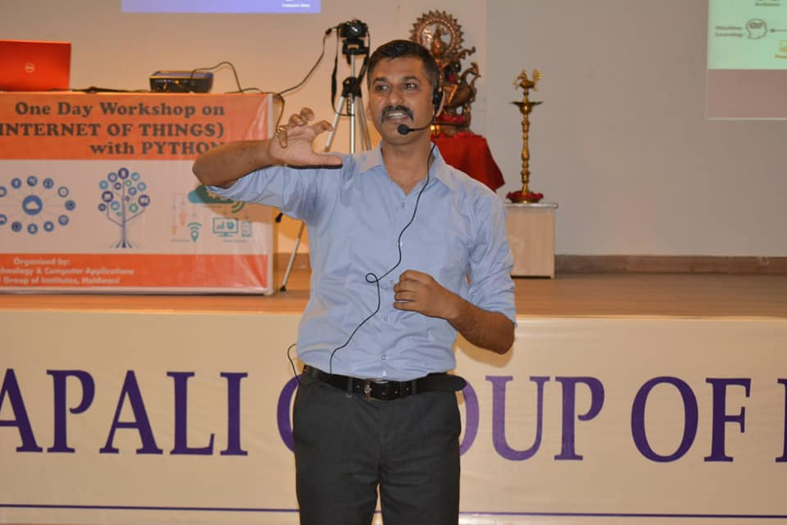

4)ORIENTATION PROGRAMME FOR B.Tech/ Diploma/B.Sc students.

Newly admitted B. Tech, B. Sc. (Hons.) and Polytechnic Diploma students were warmly welcomed by the faculty members and the students of Amrapali Institute of Technology and Sciences. A Week long Orientation Programme was hosted from 20th to 25 August 2019 to familiarize the freshers with the various Academic,Co Curricular and Extra Currilcular Activities of the Institute. In his Welcome address, Prof. (Dr.) Manoj Pandey Director AITS stressed on the importance of hard work and sincerity in academic life. He urged the students to focus on their holistic development with a balance between academics and co curricular activities. He wished the students a fruitful and rewarding stay at AITS.
Prof (Dr. ) Narendra S. Chaudhari, Hon'ble Vice Chancellor Uttarakhand Technical University
also interacted with the students. Faculty Members of Different departments shared their words of wisdom with the students. A wide range of activities were conducted during the Orientation Week including Motivational Session, Internship and Placement Session, Cultural Session, Indoor Games and Campus Visit.
Distinguished Alumni Mr. Shivam Dutt Sharma and Mr. Harshit Pandey were also invited as Guest Speakers during the Orientation Programme.
