National Deworming Day@AIPS

The Union Ministry of Health and Family Welfare launched National Deworming program on the occasion of National Deworming Day observed on 10 February. This is one of the largest public health programs reaching large number of children during a short period. According to World Health Organization 241 million children between the ages of 1 and 14 years are at risk of parasitic intestinal worms in India, also known as Soil-Transmitted Helminths.
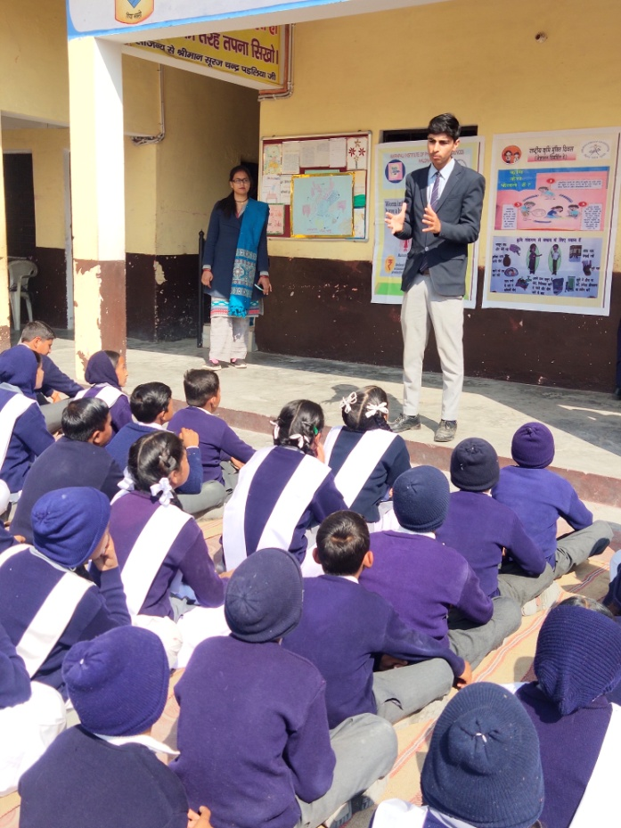

About Soil- Transmitted Helminths: Worm which are transmitted through soil contaminated with faecal matter are called soil transmitted Helminths, these are intestinal parasitic worms.
Roundworm (Ascaris lumbricoides), Whipworm (Trichuris trichiura) and hookworms (Necator americanus and Ancylostoma duodenale) are worms that infect people.
Aim:
The aim of the day is to deworm all preschool and school-age children between the age of 1-19 years in order to improve their health, mental development, nutritional status and quality of life.
Program:
Amrapali Institute of Pharmacy and sciences and Health & wellness Club of Amrapali Group of Institute organized an Awareness Program on National Deworming day on 10th Feb 2020.Students of B.pharm and D.pharm interacted with students of Pt. Badridutt Padaliya Saraswati Shisu Mandir, Lamachaur Haldwani and share their knowledge about Deworming. How person get infected with worms and what are their symptoms and preventions and also hygiene.

