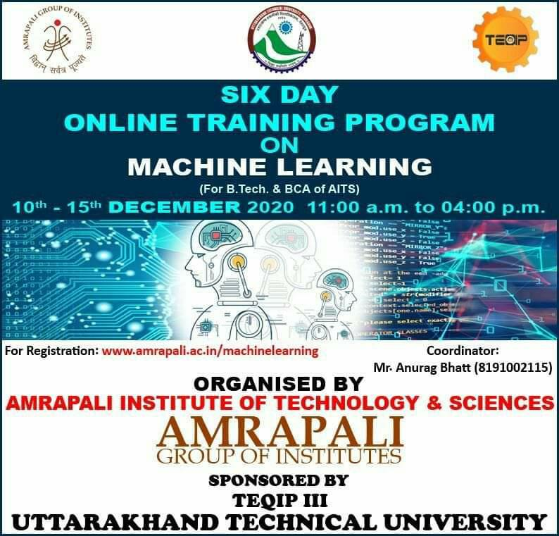

Amrapali Institute of Technology and Sciences and Uttarakhand Technical University jointly organized a 6 Day Online Student Development Program on Machine Learning from 10th - 15th December 2020 under TEQIPIII.

The Experts for the Online Learning Program were Mr. Mohd. Rashid, Ms. Anchal Sharma and Mr. Nitin Chandola. Prof. (Dr.) M. K. Pandey, Director AITS warmly welcomed the Experts and the students to the Workshop during his Address. He said that the students must keep themselves updated with the latest technologies during this age of intense competition. He also assured that similar Workshops will be organized in the future too.

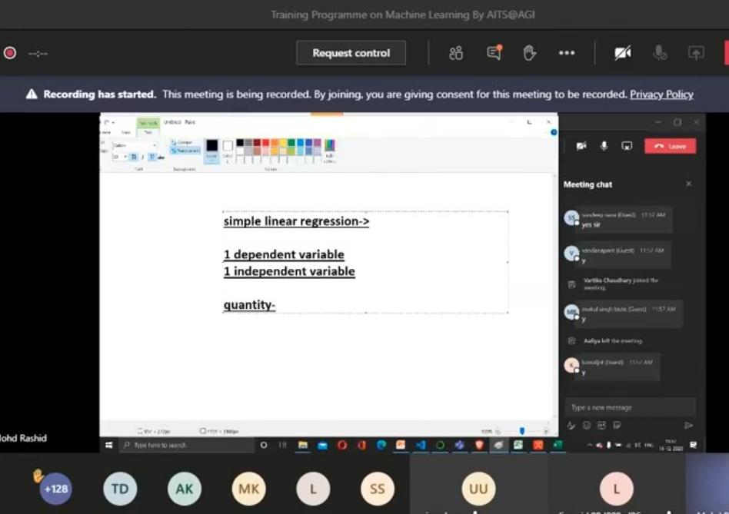

269 Students actively participated in the learning sessions. The Students learnt the various aspects of Machine Learning and related fields such as Artificial Intelligence, Data Mining and Data Sciences etc. Students grasped the various applications and scope of Machine Learning in a lot of day-to-day tasks like Number plate Detection, Fraud Detection, Email, Review and Feedback analysis, Face Detection and age prediction, Emotion Detection Automated Car-parking etc.

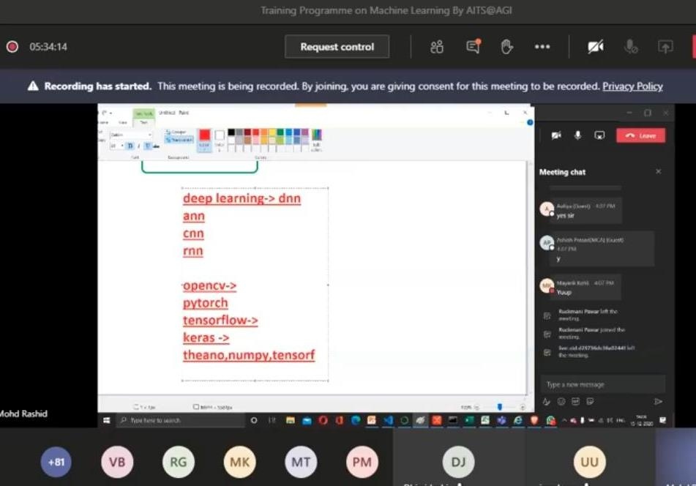

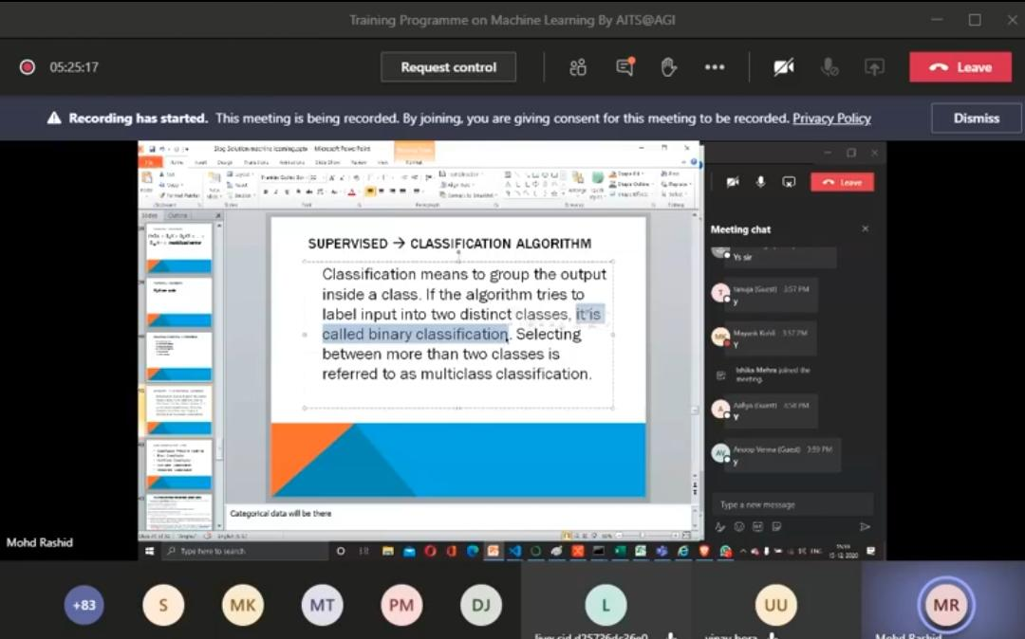

Students understood the concepts behind the two major categories of
Machine Learning which are supervised learning and unsupervised learning. Supervised learning refers to prediction with human intervention whereas unsupervised learning does not. Students also learnt how these two concepts are more related with what they want to do with the data.

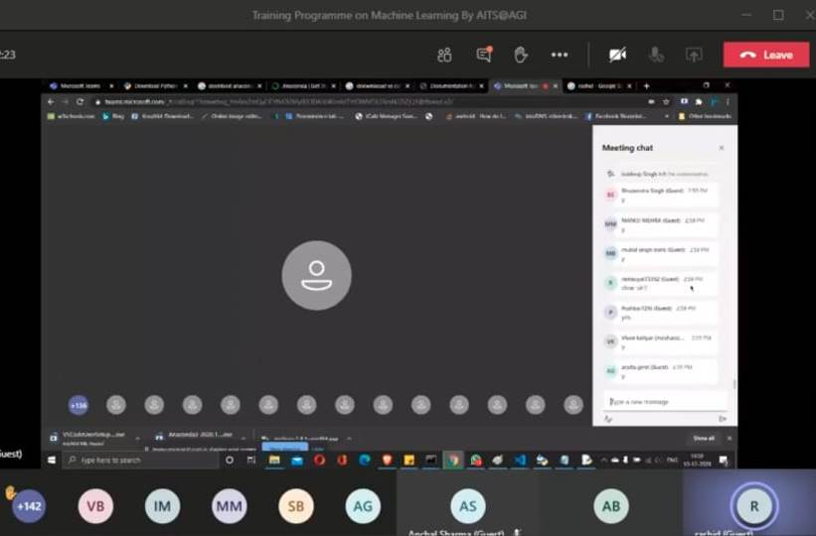

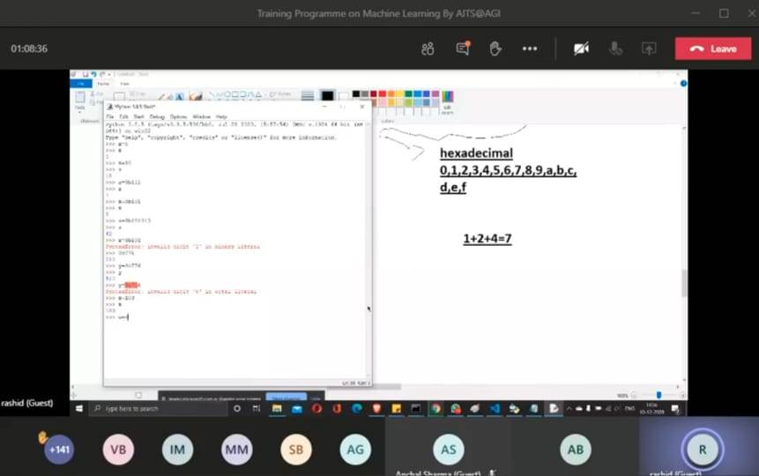

The Vote of Thanks was proposed by Mr. Anurag Bhatt, Coordinator of the Workshop. The Technical support and Media support was provided by Dr. Nitin Deepak, Dr. Hitendra Jalal and Mr. Rahul Palaria respectively.

