Student Development Program on CATIA

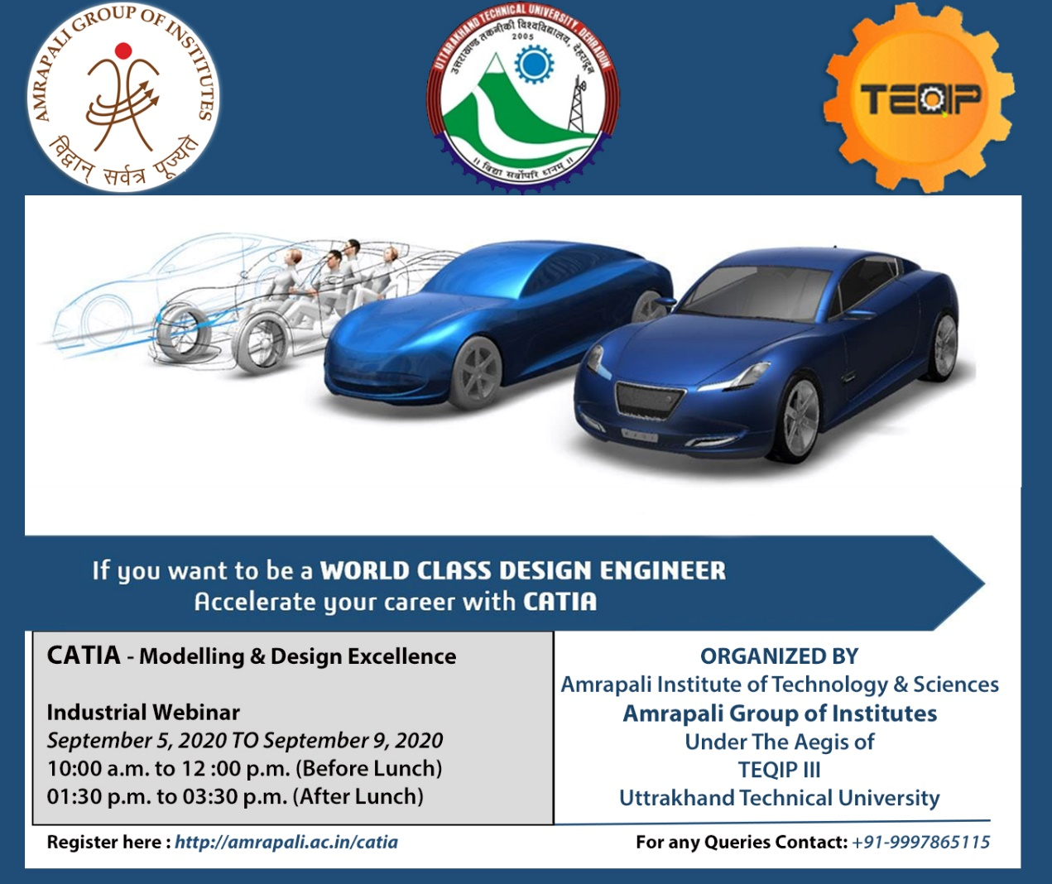

Amrapali Institute of Technology and Sciences and Uttarakhand Technical University jointly organized a 5 Day Online Student Development Program on CATIA- Modelling & Design Excellence from 5th - 9th September 2020 under the aegis of TEQIP III.

A Five-day student development program on CATIA began at Amrapali Institute of Technology and Sciences on Saturday. The student development program is aimed at enhancing the students of Mechanical Engineering with modern engineering design and simulation tools. The Experts for the Online student development Program was Mr. Rahul Sudhakar Rao Konde. Director Prof. (Dr.) M. K. Pandey, Director AITS inaugurated the workshop. Speaking on the occasion, he said that the workshop was being conducted with experts from the industry and the students must keep themselves updated with the latest technologies and advances during this age of intense competition. Skills, Real Time, information and Updated learning are the aspects which tackle the students from the industry. To overcome those aspects, the Institute had been imparting coaching, workshops and development programs to the students in the much-needed field. By knowing these courses, the students would be in a position to face practical challenges in industry and apart from learning skills these type of programs also would help them in facing interviews, he added.
An overview on the importance of 3D modelling software in modern industries was given by coordinator Mr. Hitendra Bankoti. Industry expert Mr. Rahul Sudhakar Rao Konde started the program on CATIA which comprises of a basic Introduction to CATIA V5 followed by demonstration of various tools for Part Modelling. Student development program also included hands on practice session for 3Dimensional Part Modelling & Design to make students acquainted with this software. Part Modelling was followed by Assembly Design & analysis of the system. Students were delighted to participate in this program & they look forward to attend more such type of programs & workshops in future.
The session was concluded by Vote of Thanks, proposed by Mr. Hitendra Bankoti, Coordinator of the Workshop. The Technical support and Media support were provided by Dr. Nitin Deepak, Dr. Hitendra Jalal and Mr. Rahul Palaria respectively.

