Content for Website
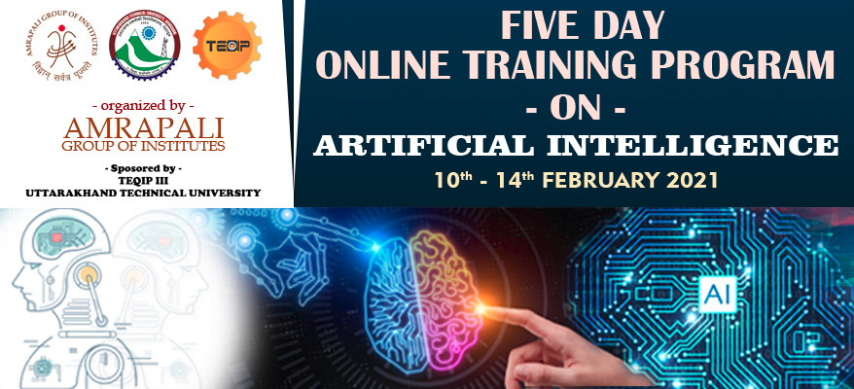

Amrapali Institute of Technology and Sciences and Uttarakhand Technical University, Dehradun jointly organized a 5 – Day Online Training Program on “ARTIFICIAL INTELLIGENCE” from 10th February – 14th February 2021 under TEQIP - III.
The Online Training Program started with an introduction to Artificial Intelligence and fundamentals of Python Language. ‘NumPy’, a very useful Python library was discussed and its function was explained for working in domain of linear algebra, Fourier transform, and matrices. In continuation to learning process training about pandas package was given. It was well explained that how Pandas allows us to analyze big data and make conclusions based on statistical theories. Introduction about python’s popular package matplotlib (low level graph plotting library in python that serves as a visualization utility) was also discussed during the program. In the last session the expert presented some projects, developed in Python. The projects were developed using popular technologies like NumPy, pandas, matplotlib, tkinter (Python GUI Tool) etc. This Online training program was a great learning process which enlightened the attendees and motivated them to enhance their professional skills and expertise.

