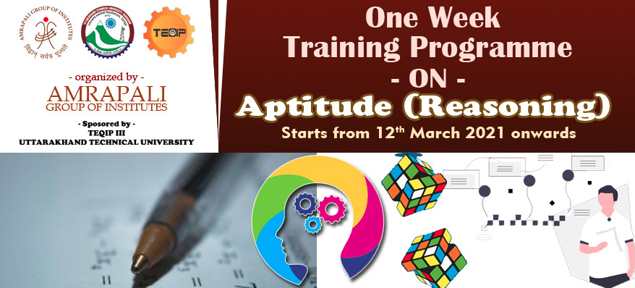
Amrapali Institute of Technology and Sciences and Uttarakhand Technical University jointly organized a One Week Training Program On Aptitude (Reasoning) from 12th March 2021 onwards under TEQIP-III.
The Experts for the Online Learning Program were Mr. Himanshu Gupta and Mr. Ashuthosh.
Prof. (Dr.) M. K. Pandey, Director AITS warmly welcomed the Experts and the students to the Student Development Program during his Address. He said that all the students required having expertise in solving aptitude and reasoning question which will help the students to get their job in efficient manner. He also assured that similar Workshops will be organized in the future too.
Near about 100 Students actively participated in the learning sessions. The Students learnt the various methods of aptitude and reasoning. This training is conducted to boost-up candidate’s Problem solving ability and to test how efficiently a student can respond to a task or a situation. The areas those are generally tested are Numerical Ability and Quantitative Aptitude, Logical reasoning, Data sufficiency and Interpretation.
The Vote of Thanks was proposed by Dr. Suresh Chandra Wariyal, Coordinator and Mrs. Preeti Pandey Co-Coordinator of the Workshop. The Technical support and Media support was provided by Dr. Nitin Deepak and Mr. Rahul Palaria.
